## The Turn Lane Tool

This tool is used for making a slip lane or a turning lane.

**To create a turning lane:**

* Select the **Turn Lane** tool from the Roads tab in the Tools Palette
* Assuming you are adding this to a pre-existing road, click on the road where you want the turning to start
* Click again around the middle of the turning lane to place a control point
* Place your final click where you want your turning lane to end
* Right click to drop the tool
* 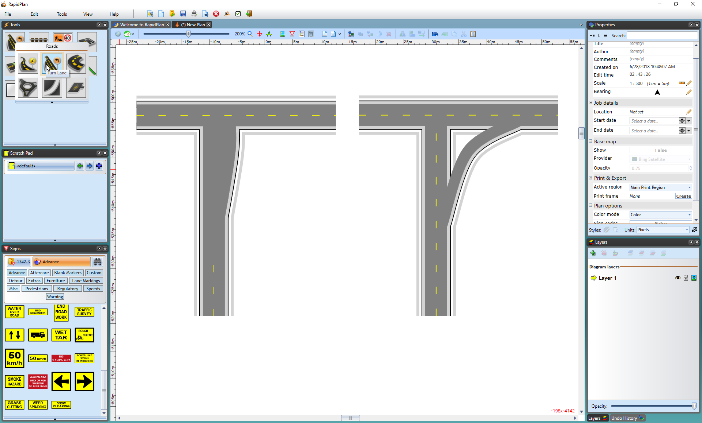
* Turning_Lane_on_left_and_a_Slip_Lane_on_right_using_the_Turn_Lane_tool